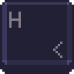

**MACROHARD**

System Plan Document

Team 1

ERYK CYGIELSKI

ANDREA BIALKOWSKI

NERMIN DEDOVIC

RANDY LY

JITEN PATEL

RAMEEZ ANWAR

DIMITRI VITYK

10/25/2020

**Overview**

The proposed system for MacroHard is to incorporate various tools to produce a successful platform. The database will be created on PostgreSQL and the backend will be coded in Node.js, using express. The front-end will be created using HTML, CSS and JavaScript and it will all be hosted on a local machine. An overview of the data flow will be the Database to Node.js to the local machine and then to the User creating a simple sequence.

## **Design Plan**

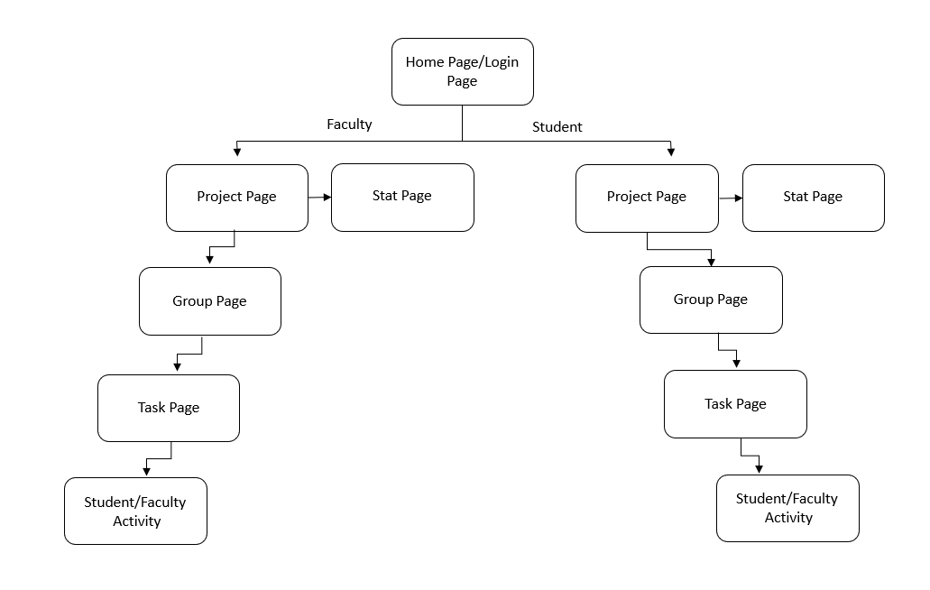

## 

## **Database design**

Data Flow and Database Design Diagram

## **Deployment Plan**

The deployment plan for MacroHard will begin with connecting the front-end designs as shown above with the database that will hold all information. Once this connection is created, then the MacroHard application will be launched for testing. After testing the application will be released.

## **testing Plan**

The back-end testing has begun on the week of 19th of October and will continue throughout the week of 26th.

|  |  |
| --- | --- |
| Name | Role |
| Nermin Dedovic | Back-end coding and Database |
| Randy Ly | Front-end design |
| Andrea Bialkowski | Technical Writing/Documentation |
| Eryk Cygielski | Front-end design |
| Jiten Patel | Front End Design |
| Rameez Anwar | Back-end coding and Database |
| Dimitri Vityk | Front End Design |

TEST PLAN

Backend testing – Nermin, Rameez

Frontend testing – Nermin

Overall testing – Nermin, Randy

TEST PHASES:

Test using user account

Test using faculty account

Test using administrator account

TEST LOCATION:

Test on desktop browser

Test on mobile browser

Test with links

SCHEDULE:

Testing will begin the second week of October 26th.

## 

## **Design Specs**

Figure 1 - Login Screen

Figure 2 – Create an Account

Figure 3 – Recover Account/Email sent

Figure 4 – Recover Account Username

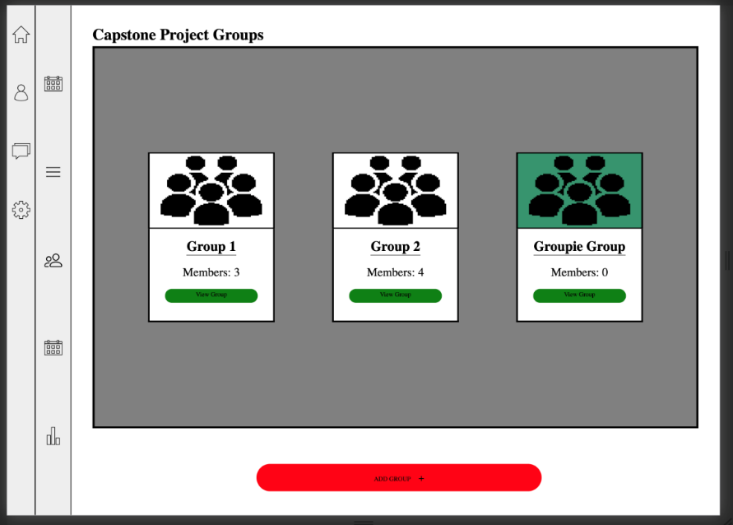Figure 5 – Project Groups Page

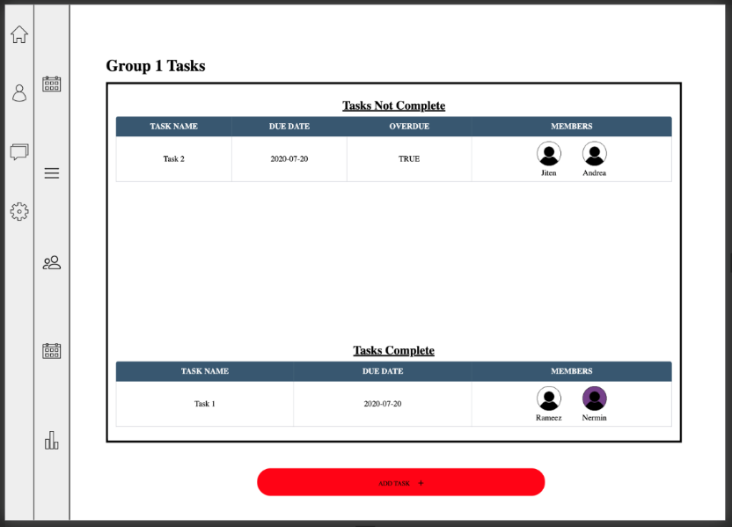Figure 6 – Group Tasks Page

Figure 7 – Group Tasks Page

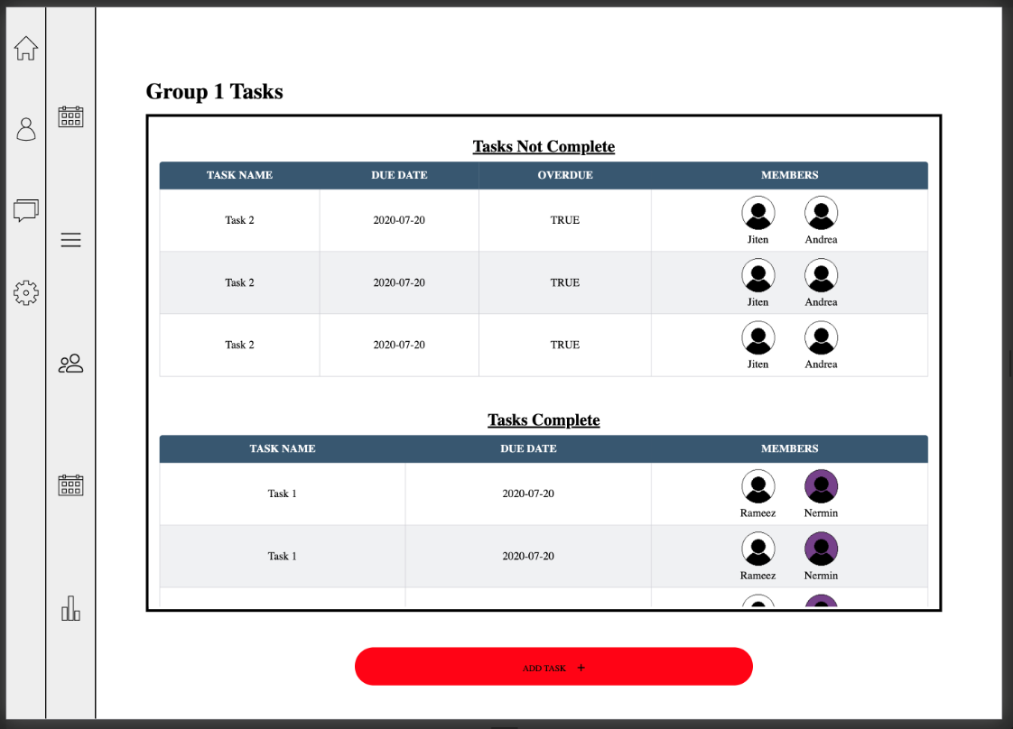

Figure 8 – Profile Page

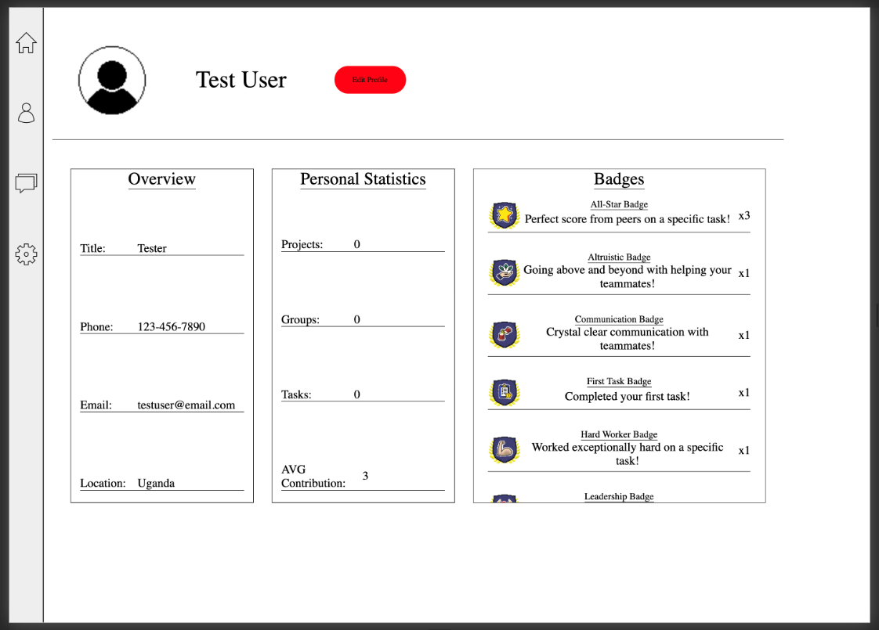

Figure 9 – Project Members/Faculty Page

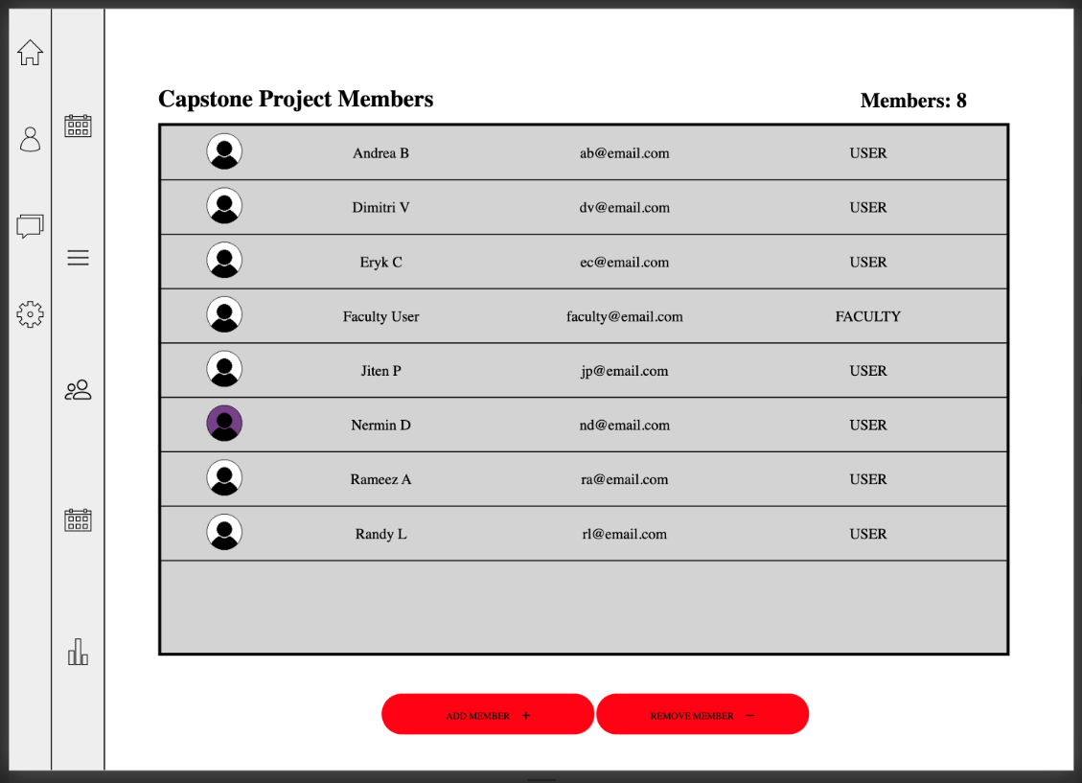

Figure 10 – Project Members Reg User Page

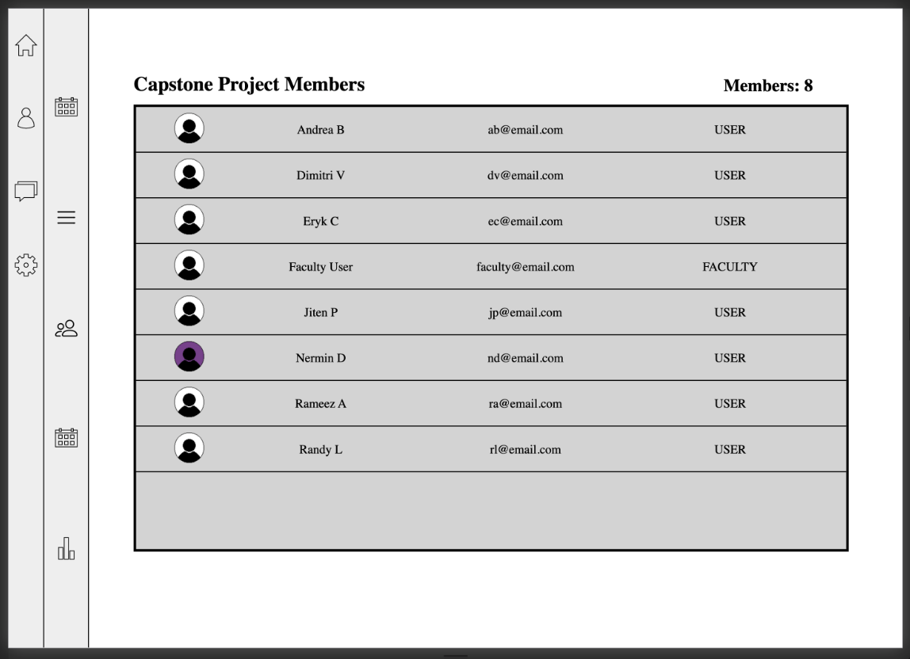

Figure 11 – Projects Page

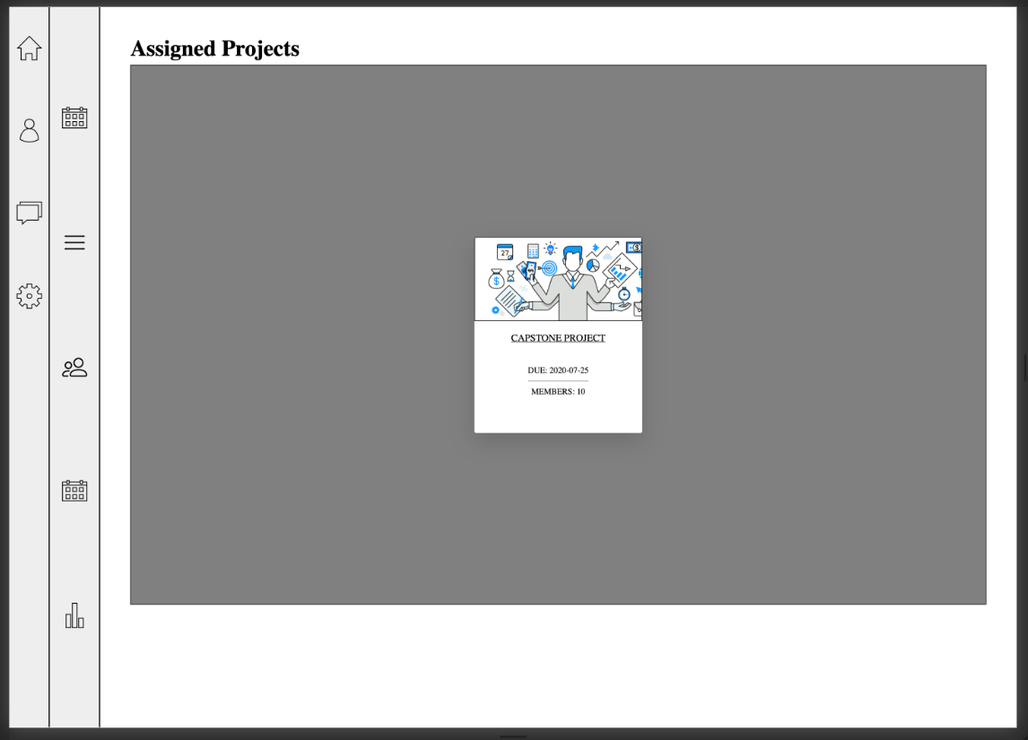

Figure 12 – Stats Page Chart Tab Page

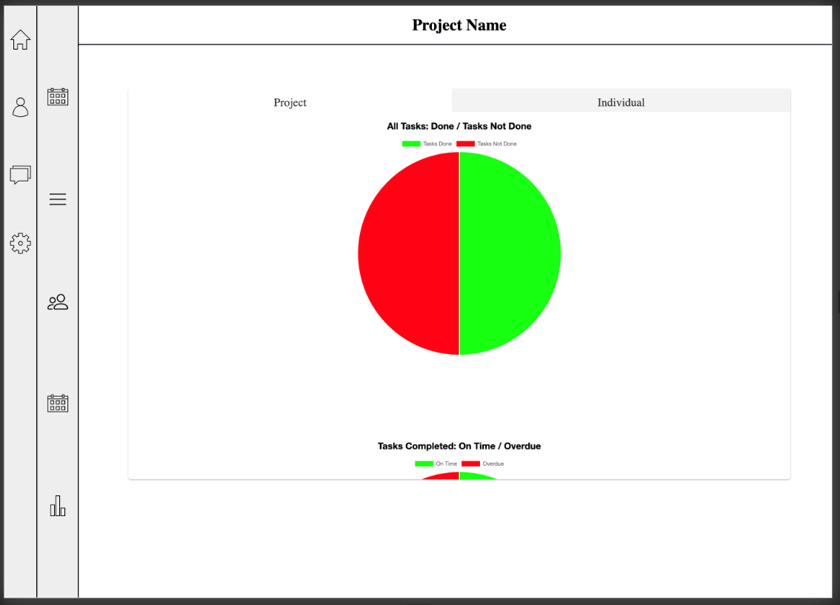

Figure 13 – Stats Page Table on Faculty

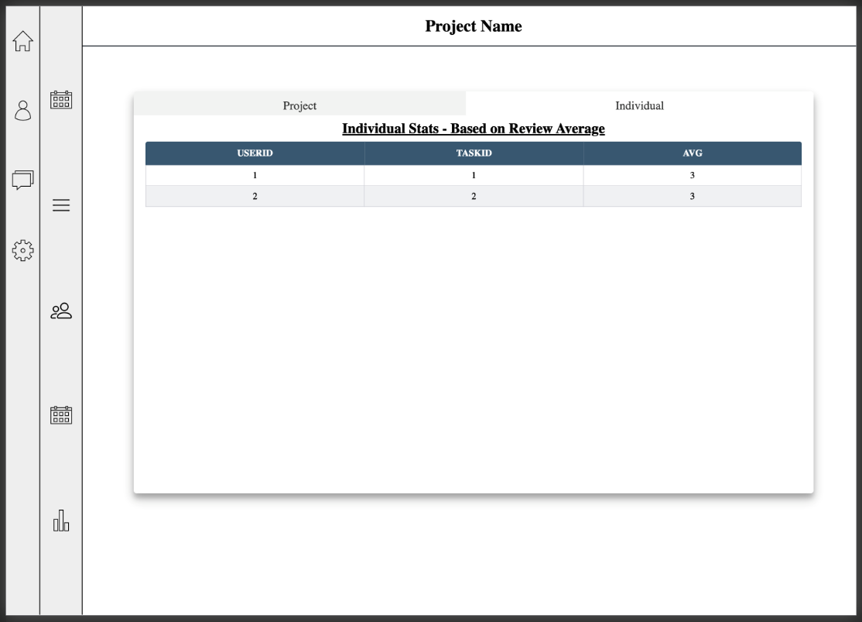

Figure 14 – Stats Page Table on Faculty

